System and Software Architecture Description (SSAD)

Study App

Justice League

Jeffrey Woo
Joan Sirma
Manisha Yalavarthy
Soneer Sainion
Vishal Ravuri

<Date>

Version History
Date | Author | Version | Changes made | Rationale
08/25/05 | PA | 2.0 | - Original template for use with Instructional ICM-Sw v1.0 | - Initial draft for use with Instructional ICM-Sw v1.0
05/22/09 | SK | 2.1 | - Embedded description in each Table | - To be consistent with ICM EPG template set standard V2.1
10/04/16 | BO | 2.2 | In Technology-Independent Model Design  - Added conceptual domain model  - Separated "Process Realization Diagram" into "Robustness diagram" and "Sequence Diagram" | - For research data collection

Table of Contents
System and Software Architecture Description (SSAD) i
Version History ii
Table of Contents iii
Table of Tables iv
Table of Figures v
1. Introduction 1
1.1 Purpose of the SSAD 1
1.2 Status of the SSAD 1
2. System Analysis 2
2.1 System Analysis Overview 2
2.2 System Analysis Rationale 5
3. Technology-Independent Model 6
3.1 Design Overview 6
3.2 Design Rationale 8
4. Technology-Specific System Design 9
4.1 Design Overview 9
4.2 Design Rationale 10
5. Architectural Styles, Patterns and Frameworks 11

Table of Tables
Table 1: Actors Summary 2
Table 2: Artifacts and Information Summary 3
Table 3: Process Description 4
Table 4: Typical Course of Action 4
Table 5: Alternate Course of Action 4
Table 6: Exceptional Course of Action 4
Table 7: Hardware Component Description 7
Table 8: Software Component Description 7
Table 9: Supporting Software Component Description 7
Table 10: Design Class Description 8
Table 11: Hardware Component Description 9
Table 12: Software Component Description 9
Table 13: Supporting Software Component Description 10
Table 14: Design Class Description 10
Table 15: Architectural Styles, Patterns, and Frameworks 11

Table of Figures
Figure 1: System Context Diagram 2
Figure 2: Artifacts and Information Diagram 3
Figure 3: Process Diagram 4
Figure 4: Conceptual Domain Model 6
Figure 5: Hardware Component Class Diagram 6
Figure 6: Software Component Class Diagram 6
Figure 7: Deployment Diagram 6
Figure 8: Supporting Software Component Class Diagram 7
Figure 9: Design Class Diagram 8
Figure 10: Robustness Diagram 8
Figure 11: Sequence Diagram 8
Figure 12: Hardware Component Class Diagram 9
Figure 13: Software Component Class Diagram 9
Figure 14: Deployment Diagram 9
Figure 15: Supporting Software Component Class Diagram 9
Figure 16: Design Class Diagram 10
Figure 17: Process Realization Diagram 10

Introduction

Purpose of the SSAD

The purpose of this document is to provide a detailed architectural overview of our Android Application, StudyApp. Different components of the application are described in various architectural views in this document, creating an outline and roadmap of which architectural decisions were seceded upon.

Status of the SSAD

This document is currently at version 0.1 as of 3/13/2017.

System Analysis

System Analysis Overview
The primary purpose of the StudyApp is to let create a platform where users have access to relevant and useful study material for various of subject. StudyApp is a central location for useful resources around the web. These resources include videos, lesson notes and review quizzes. Users also have the ability to save or share resources.

System Context
<< This section should contain the system's context, in the form of a UML Class Diagram showing the actors and their relations to the system. More information and example can be found in ICM EPG> Task: Analyze the Proposed System >>
<<System Context Diagram>>
Figure 1: System Context Diagram

Table 1: Actors Summary
Actor | Description | Responsibilities
Student User | Student users that can view, save and share resources | - View Resources  - Save Resources  - Share Resources
Instructor User | Instructor users can do everything a student user can do but can also add resources | - View Resources  - Save Resources  - Share Resources  - Add Resources
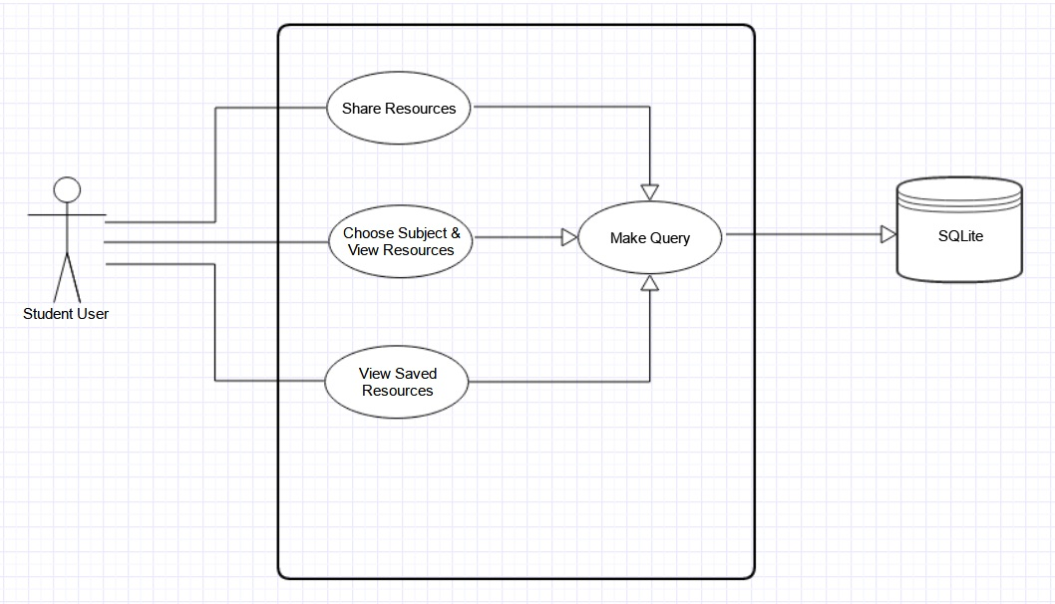
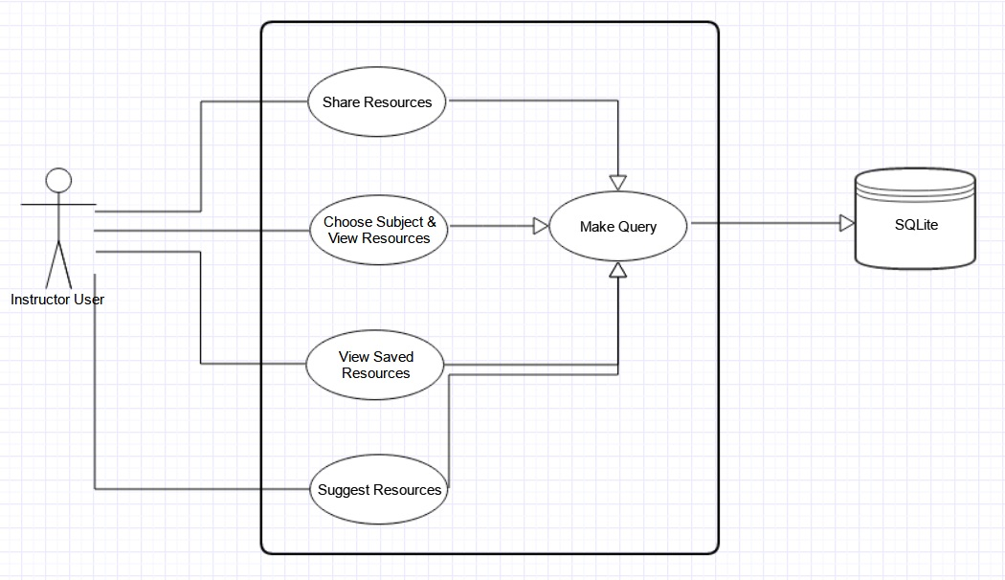

Artifacts & Information
<< This section of the document describes the artifacts and information created by the system. These artifacts can either be used by the end user or reused by the system to produce further artifacts.
This section should contain:
- a UML class diagram showing the artifacts that the system being developed will inspect, manipulate, and/or produce
- and for each artifact shown in the UML class diagram, the artifact's name and its purpose.

More information and example can be found in ICM EPG> Task: Analyze the Proposed System. >>

<<Artifacts and Information Diagram>>
Figure 2: Artifacts and Information Diagram
Table 2: Artifacts and Information Summary
Artifact | Purpose
Database | Stores links to all resources  Stores user saved resources
.APK | The executable file for the application
Manifest file | Has all permission and resources of the application

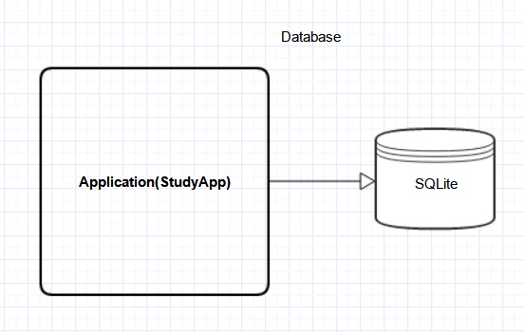
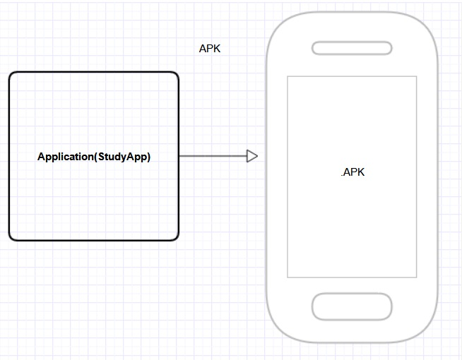
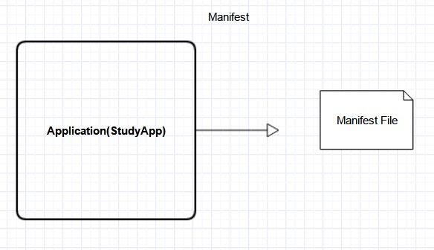

Behavior
<< This section should contain:
- One or more UML Use-Case Diagrams showing the processes whereby actors and the system interact in order to accomplish a goal that benefits at least one of the actors.
- For each use case shown in the UML use case diagram(s):
- The assigned identifier (name) of the use case
- The purpose of the use case
- The requirement(s) listed in the SSRD that are (completely or partially) covered by the use case.
- The risks associated with developing/implementing the use case.
- The pre-conditions for invoking the use case
- The post-conditions that exist after the use case has been completed
- English descriptions of the use case's standard (sunny day) course of action and its alternate (rainy day) course(s) of action.
More information and example can be found in ICM EPG> Task: Analyze the Proposed System. >>

<<Use-Case Diagram>>
Figure 3: Process Diagram

Capability x

Process y
Table 3: Process Description
Identifier | View Resource
Purpose | Allow user to navigate and view a certain resource
Requirements | GUI(Activity, List Views, Controllers), Database
Development Risks | Few, Database errors such as table corruption
Pre-conditions | Database is created successfully in Application
Post-conditions | Database is not corrupted and updated properly

Table 4: Typical Course of Action
Seq# | Actor’s Action | System’s Response
1 | Opens App | Shows MainActivty
2 | Choose Look For Subject | Shows List of Subjects
3 | Clicks A Subject | Shows List Of Resources
4 | Clicks Resource | Does appropriate Action
Table 5: Alternate Course of Action
Seq# | Actor’s Action | System’s Response
1 | Opens App | Shows MainActivty
2 | Choose Look For Subject | Shows List of Subjects
3 | Clicks A Subject | Shows List Of Resources
4 | Clicks Saves Resource | Updates User Database
Table 6: Exceptional Course of Action
Seq# | Actor’s Action | System’s Response
1 | Opens App | Shows MainActivty
2 | Choose Look For Subject | Shows List of Subjects
3 | Clicks A Subject | Shows List Of Resources
4 | Clicks Resource | Catches Broken Link Error

Modes of Operation

<< For projects involving systems that operate in more than one mode this section should contain a description of the system's behavior in each of its modes. More information and example can be found in ICM EPG> Task: Analyze the Proposed System. >>

System Analysis Rationale

<< This section should list and explain aspects of the analysis that are deemed by the team to be less than obvious or actually counter-intuitive and for which, as a result, there is a high risk that readers will not understand or will misunderstand what is intended. More information and example can be found in ICM EPG> Task: Analyze the Proposed System. >>

Technology-Independent Model

Design Overview

System Structure
<< This section should contain
- a conceptual domain model
- a UML hardware component class diagram
- a UML software component class diagram
- a UML deployment diagram
- If necessary, a class diagram for the system's supporting software infrastructure
- and descriptions of the hardware components, software components, and, if necessary, the supporting software infrastructure components of the technology/platform-independent system architecture
More information and example can be found in ICM EPG> Task: Define Technology-Independent Architecture >>
<<Conceptual Domain Model>>
Figure 4: Conceptual Domain Model

<<Hardware Component Class Diagram>>
Figure 5: Hardware Component Class Diagram

<<Software Component Class Diagram>>
Figure 6: Software Component Class Diagram

<<Deployment Diagram>>
Figure 7: Deployment Diagram

<<Optional: Supporting Software Infrastructure Diagram>>
Figure 8: Supporting Software Component Class Diagram

Table 7: Hardware Component Description
Hardware Component | Description

Table 8: Software Component Description
Software Component | Description

Table 9: Supporting Software Component Description
Support Software Component | Description

Design Classes
This section should contain:
- UML class diagrams showing all the boundary, entity, and control classes in the design of the system being developed
- and a description of each class in the diagram
More information and example can be found in ICM EPG> Task: Define Technology-Independent Architecture >>
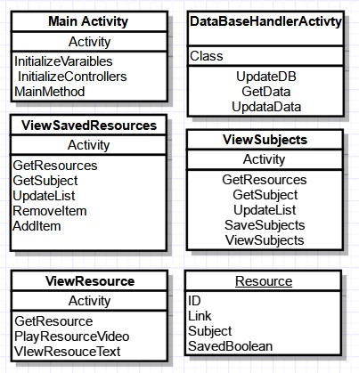

<Classes n>
<<Design Classes Class Diagram>>
Figure 9: Design Class Diagram

Table 10: Design Class Description
Class | Type | Description
MainActivity | Activity | Home Screen Of the application, shows view saved resource or look for subjects
ViewSavedResources | Activity | Shows list of saved resources
ViewResource | Activity | Shows a specific Resource
ViewSubjects | Activity | Shows List of study subjects
DatabaseHandler | Class | Deals with communication to Database
Resource | Object | Is a resource object

Process Realization
<< This section shows how the proposed architecture can be realized by conducting robustness analysis and constructing sequence diagrams. More information and example can be found in ICM EPG> Task: Define Technology-Independent Architecture >>
<<Robustness Diagram>>
Figure 10: Robustness Diagram
<<Sequence Diagram>>
Figure 11: Sequence Diagram

Design Rationale

<< This section should contain an explanation of how/why the architecture/design described in previous sections was chosen. More information and example can be found in ICM EPG> Task: Define Technology-Independent Architecture >>

Technology-Specific System Design
<< Once you know specific technology that you team is going to use, design the system and software architecture and document them in this section. >>

Design Overview

System Structure
<<Hardware Component Class Diagram>>
Figure 12: Hardware Component Class Diagram

<<Software Component Class Diagram>>
Figure 13: Software Component Class Diagram

<<Deployment Diagram>>
Figure 14: Deployment Diagram

<<Optional: Supporting Software Infrastructure Diagram>>
Figure 15: Supporting Software Component Class Diagram

Table 11: Hardware Component Description
Hardware Component | Description

Table 12: Software Component Description
Software Component | Description
SQLite Database | Android stock database for storing data
Activities/XML | For View and Controllers
View Components | For GUI

Table 13: Supporting Software Component Description
Support Software Component | Description
WEB embedded | View a webpage on app
Video embedded | View video on app

Design Classes

<Classes n>
<<Design Classes Class Diagram>>
Figure 16: Design Class Diagram

Table 14: Design Class Description
Class | Type | Description
MainActivity | Activity | Home Screen Of the application, shows view saved resource or look for subjects
ViewSavedResources | Activity | Shows list of saved resources
ViewResource | Activity | Shows a specific Resource
ViewSubjects | Activity | Shows List of study subjects
DatabaseHandler | Class | Deals with communication to Database
Resource | Object | Is a resource object

Process Realization
<<Process Realization Diagram>>
Figure 17: Process Realization Diagram

Design Rationale

Architectural Styles, Patterns and Frameworks
<< Describe any implementation architecture styles (e.g. the Prism style and 3-tier architecture), patterns (e.g. pipe-and-filter and client-server), or frameworks (e.g. Java and CORBA) used to describe the system architecture. >>
Table 15: Architectural Styles, Patterns, and Frameworks
Name | Description | Benefits, Costs, and Limitations

